Course Focus
AGSC 491 Plant Nutrition and Soil Fertility Management - Mac Burgess
Crop Science and Environmental Horticulture Science Majors in the Department of Plant Science and Plant Pathology, as well as students in the interdisciplinary Sustainable Food and Bioenergy Systems Program have a new option for learning about managing plant nutrition and soil fertility in applied settings. In this new course, offered this fall and currently under review for approval as a 300-level course in AGSC, students will pursue the following learning outcomes:

Know the essential plant nutrients, their functions in plant growth, uptake mechanisms, fertilizer sources, and deficiency/toxicity symptoms.

Describe how soil and water store, transport, and mediate the cycling and uptake of plant nutrients.

Calculate application rates for soil amendments, including fertilizer, manure, and compost, to meet plant nutrition needs in field crop, turf grass, home garden, greenhouse, and rangeland settings, based on soil test results and research-based extension publications.

Estimate the contribution of organic nutrient cycling to plant nutrition under various management systems in different environmental contexts.

Apply knowledge of plant nutrition to real-world management scenarios in horticultural, agronomic, and rangeland settings.

Assess the environmental impact of soil fertility management decisions.

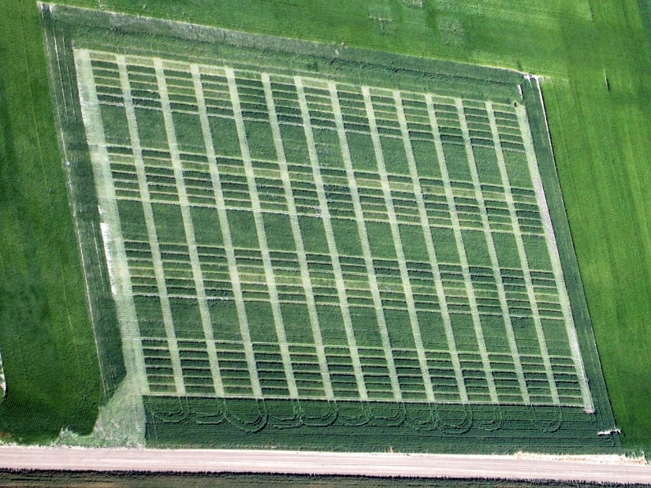
The course will be taught in a teaching lab in the Plant Growth Center. We will begin with a thorough review of the chemistry of the essential plant nutrients. We will then prepare modified Hoagland’s solutions for use in a greenhouse project where we will intentionally induce nutrient deficiencies in hydroponic barley. We will then practice diagnosis of nutrient deficiency by visual assessment, chlorophyll measurement, and plant tissue analysis. Finally, we will practice soil sampling and extraction procedures and learn how to interpret soil test reports.
Aerial photo showing the interaction of pea and lentil cover crop management and N fertilizer on Nitrogen uptake of Choteau spring wheat near Amsterdam, MT in 2011.

Aerial photo showing the interaction of pea and lentil cover crop management and N fertilizer on Nitrogen uptake of Choteau spring wheat near Amsterdam, MT in 2011.

